Impact of Homogeneously Dispersed Al Nanoclusters by Si-monolayer Insertion into Hf0.5Zr0.5O2 Film on FeFET Memory Array with Tight Threshold Voltage Distribution K. Maekawa1, T. Yamaguchi2, T. Ohara1, A. Amo1, E. Tsukuda1, K. Sonoda1, H. Yanagita1, M. Inoue2, M. Matsuura2, and T. Yamashita1   
 1Device Technology Div., 2Process Production Technology Div., Renesas Electronics Corp, Hitachinaka, Ibaraki, Japan, email: keiichi.maekawa.fn@renesas.com

***Abstract***— Threshold voltage (*Vth*) variation for ferroelectric field-effect transistor (FeFET) memory using Hf0.5Zr0.5O2 (HZO) films with Al nanoclusters is investigated. We show that Si-monolayer formed over Al nanoclusters effectively reduces the variation, due to suppressing the migration and aggregation of Al nanoclusters, resulting that the orientation and the growth rate for each ferroelectric domain is successfully aligned. The effect is more evident for the erase state at which the potential fluctuation of the substrate side is superposed on the *Vth* variation.

|  |  |  |  |  |  |
| --- | --- | --- | --- | --- | --- |
| Ferroelectric | **I.** | **INTRODUCTION** | | (FeFETs) | with |
| field-effect | | transistors |

orthorhombic-phase HfO2 film have gained significant attention as embedded nonvolatile memories because of CMOS compatibility and device scalability [1]. However, there are few experimental reports about the threshold voltage (*Vth*)variation for the HfO2-based FeFET memory, which is crucial for scaled memory array operation. Dunkel et al. [2] have reported that the *Vth* variation of the two polarization states, high-*Vth* and low-*Vth* states, are overlapping for industrial scaled FeFETs. The stabilization of the ferroelectric properties in HfO2 filmwas examined through the doping with various elements, such as Si-doping etc. [3], and the controlling of grain growth for the ferroelectric polycrystalline film [4]. Recently, some of the authors have reported that the embedding Al nanoclusters in ferroelectric Hf0.5Zr0.5O2 (HZO) film tends to adjust the crystal orientation of orthorhombic grains to [001] and the memory characteristics of the HZO based FeFET with the embedded Al nanoclusters is demonstrated [5,6].

In this paper, we revealed by device simulation that fluctuation of polarization orientation induces the large *Vth* variation for low-*Vth* state, and demonstrated that the embedding Al nanoclusters in the HZO based FeFET memory suppress the *Vth* variation after the polarization hysteresis loop measured. Furthermore, we demonstrated that Si-monolayer insertion intothe HZO film with Al nanoclusters suppressed the *Vth* variation after the erase pulse applied. The transient behavior of the polarization in the FeFET memory is discussed and compared with the classical switching models of the ferroelectric film [7,8]. Finally, we concluded that Si-monolayer insertion aligns the growth rate for ferroelectric domains due to suppressing the migration and aggregation of Al nanoclusters and reduces the switching speed variation in FeFET.

**II.EXPERIMENTAL**

Fig. 1 shows the fabrication flow of the HZO based FeFET. We evaluated three types of FeFETs using HZO films with the embedded Al nanoclusters (FeFET with Al), the Al nanoclusters covered by the Si-monolayer (FeFET with Al+Si), and the non-doped (non-doped FeFET).These devices were fabricated on 300 mm wafers using the 65-nm node conventional bulk CMOS process with interlayer (IL), ferroelectric dielectric (FE) and poly gate stack deposition. 2-nm-thick SiON IL was formed on a p-type well by thermal oxidation. A HZO film (Hf:Zr = 1:1) with hafnium

|  |  |  |  |  |
| --- | --- | --- | --- | --- |
| tetrachloride | (HfCl4/H2O) | and | zirconium | tetrachloride |

(ZrCl4/H2O) precursors was deposited on the IL by atomic layer

|  |
| --- |
| deposition at 300 ºC. Al nanoclusters and Si monolayerwere |

|  |
| --- |
| inserted into the HZO film. Al nanoclusters were doped with |

|  |
| --- |
| physical vapor deposition at room temperature. The dose of Al |

|  |
| --- |
| is 5 × 1013 cm-2. Si-monolayer was deposited over Al |

|  |
| --- |
| nanoclusters with silicon tetrachloride (SiCl4/H2O) precursors |

|  |
| --- |
| by atomic layer deposition at 300 ºC. After depositing 10-nm- |

thick TiN capping layer by sputtering, rapid thermal annealing was carried out. Annealing temperature was optimized to form the ferroelectric phase of the HZO film. Fig. 2 shows the TEM cross section of the HZO based FeFET. The inset shows Al nanoclusters embedded in the HZO film.

Memory characteristics are measured by using the decoder type memory array pattern with 512-bit. The selective word line (gate) voltages for program and erase (P/E) operations were -6 and 6 V, respectively.The bit and source lines and the substrate were grounded. For physical analyses, the distribution of grain size and crystal direction in HZO films were characterized by the scanning precession electron diffraction.

**III.RESULTS AND DISCUSSION**

*A. Vth variation for the two polarization states in FeFET*

Fig. 3 shows the forward and reverse Id-Vg characteristics in the non-doped FeFET. The counterclockwise hysteresis loop shows the ferroelectric behavior. Fig. 4 shows the gate area dependence of the memory window (*MW*), the difference between high-*Vth* and low-*Vth* states, in the non-doped FeFET. *MW* is confirmed even in the small gate area devices. However, *Vth* and *MW* variation are serious issue in the scaled FeFET as shown in Figs. 5 and 6, respectively. Relative *Vth* after Vg sweep and *MW* are defined as the difference from the median values. The *Vth* variation of low-*Vth* state is larger than that of high-*Vth* state and strongly correlated to the *MW* variation.Fig. 7 shows

|  |  |  |
| --- | --- | --- |
| 978-1-7281-4032-2/19/$31.00 ©2019 IEEE | 15.4.1 | IEDM19-350 |

*Vth* variation (σ*Vth*) divided by electrical equivalent gate dielectric oxide thickness (EOT) for the non-doped FeFET and bulk NMOSFET [9]. *Vth* variation of the non-doped FeFET regardless of high-*Vth* and low-*Vth* states is larger than that of NMOSFET. *Vth* variation of NMOSFET is mainly attributed to the random dopant fluctuation.According to the classical switching models of the ferroelectric film, the switching behavior for the actual FeFET memory is also influenced by the non-uniformity of the polarization orientation and domain growth rate as shown in Fig. 8. Therefore, *Vth* variation of the FeFET memory is attributed to the fluctuation of polarization orientation and domain growth rate in the ferroelectric film. The non-uniformity of the polarization orientation and domain growth rate affects *Vth* variation even after the completely reversal of each domains and the switching speed variation in FeFET, respectively.

We performed device simulation to verify the hypothesis that the fluctuation of polarization orientation induces the large *Vth* variation for low-*Vth* state in FeFET. The ferroelectric film is divided into four domains, and one domain is replaced as a paraelectric region to evaluate the spatial fluctuation of polarization. Fig. 9 shows the calculated Id-Vg characteristics of FeFET at high-*Vth* and low-*Vth* states. The low-*Vth* state is more susceptible to the polarization orientation fluctuation than the high-*Vth* state. Moreover, the fluctuation at the source side in FeFET has the largest influence of the *Vth* variation. Fig. 10 shows the calculated electrostatic potential along dielectric/Si substrate interface with the polarization orientation fluctuation on the source side of FeFET. It is suggested that the potential fluctuation on the substrate due to the non-uniformity of the

|  |  |  |  |  |  |  |
| --- | --- | --- | --- | --- | --- | --- |
| polarization | orientation | causes | *Vth* | variation | to | be |

superimposed. The effect is more evident for the low-*Vth* state because the potential on the substrate of the low-*Vth* state is lower than that of no polarization state.

*B. The analysis of the polarization orientation fluctuation*

Fig. 11 shows the cumulative frequency distribution of relative *Vth* after Vg sweepof FeFET with Al. *Vth* variation of low-*Vth* state is almost the same as that of high-*Vth* state, which shows the merit of Al nanoclusters to reduce *Vth* variation at low-*Vth* state as shown in Fig. 5.

Fig. 12 shows the cumulative frequency distribution of relative *Vth* after the erase pulse applied during 1 μs in the three types of FeFET memory arrays. It is found that the suppression of *Vth* variation for the FeFET with Al+Si is more than 25 % enhanced as compared to that for the FeFET with Al in even short channel region as shown Fig. 13. Figs. 14 and 15 show the P-E hysteresis loop for the HZO films capacitors with almost the same thermal budget for FeFET and the improvement amounts (delta *MW*) of *MW* to the non-doped FeFET, respectively. By Si-monolayer insertion, the remnant polarization (Pr) is about 17% increased, and the delta *MW* is about 0.1V increased regardless of gate length. These results indicate that the HZO films with the Al nanoclusters covered by the Si-monolayer stabilized the ferroelectric properties.

To clarify the physical properties of HZO films with the Al nanoclusters covered by the Si-monolayer at the gate stack

formation, the crystal orientation map, the alignment against [001] and the grain size of orthorhombic phase are shown in Figs. 16 (a), (b) and 17, respectively. Here, the grains of tetragonal phase are indicated as the black areas. The orientation of orthorhombic phase is almost the same between the HZO films with and without Si-monolayer. The variation of grain size is about 6 % reduced by using HZO films with Si-monolayer. These results indicate that there are also other mechanisms, the non-uniformity of the growth rate of the ferroelectric domain, in addition to the polarization orientation fluctuation to explain the improvement of the *Vth* variation by the Si-monolayer insertion as shown in Fig. 8.

*C. The analysis of the growth rate fluctuation of domain*

We investigate the transient behavior of polarization for FeFET based on Kolmogorov-Avrami-Ishibashi switching theory [7]. The complete polarization reversal (Δ*Vth* max) is defined as *MW* after 1 ms. The domain reverse probability, which is *MW* (t) /Δ*Vth* max, as function of pulse time (t) is plotted in Fig. 18. The switching speed variation is clearly suppressed by introducing the Si-monolayer insertion.

Fig. 19 shows a feasible explanation for the improvement of the switching speed variation by the Si-monolayer insertion. We presume that Al nanoclusters assist the nucleation of polarization due to the expansion of the interface region [10]. Migration and agglomeration of Al nanoclusters by thermal budget for transistor worsen the uniformity of the size and the spatial distribution of Al nanoclusters within the HZO films. The suppression of migration and aggregation can be achieved by the Si-monolayer insertion resulting the homogeneously dispersed Al nanoclusters within HZO film. These nanoclusters assist the uniform nucleation process in the ferroelectric layers and reduced the switching speed variation in FeFET.

**IV.CONCLUSIONS**

We investigated the *Vth* variation of the HZO based FeFET memory with the Al nanoclusters. Al nanoclusters suppress the *Vth* variation due to the alignment of polarization orientation for the ferroelectric domains. The suppression of *Vth* variation for the FeFET with the Al nanoclusters dispersed within HZO films by Si-monolayer insertion imply the alignment of the growth rate for ferroelectric domain due to the suppressing the migration and aggregation of Al nanoclusters. The effect is more evident for the erase state at which the potential fluctuation of the substrate side is superposed on the *Vth* variation.

REFERENCES

[1] J. Müller et al., *IEDM*, p280 (2013).

[2] S. Dünkel et al., *IEDM*, p485 (2017).

[3] P. D. Lemenzo, *et al*., *Appl. Phys. Lett.* 107, 242903 (2015). [4] H.K. Yoo, et al., *IEDM*, p481 (2017).

[5] T. Yamaguchi, *et al., IEDM*, p165 (2018).

[6] T. Ohara, *et al., SSDM in press* (2019).

[7] I. Stolichnov, et al., Appl. Phys. Lett. 83, 163362 (2003). [8] I. Tagantsev, et al., *Physical Review B* 66 (2002).

[9] K. Takeuchi, et al. *IEDM*, p467 (2007).

[10] R.C.Garvie, J. Phys. Chem. 69(4), p.1238 (1965).

IEDM19-351 15.4.2

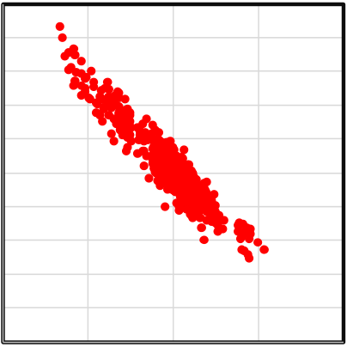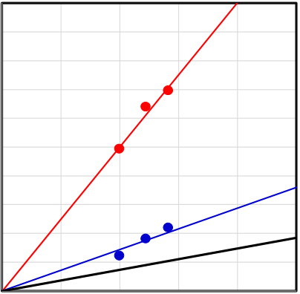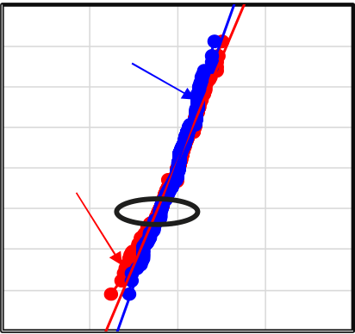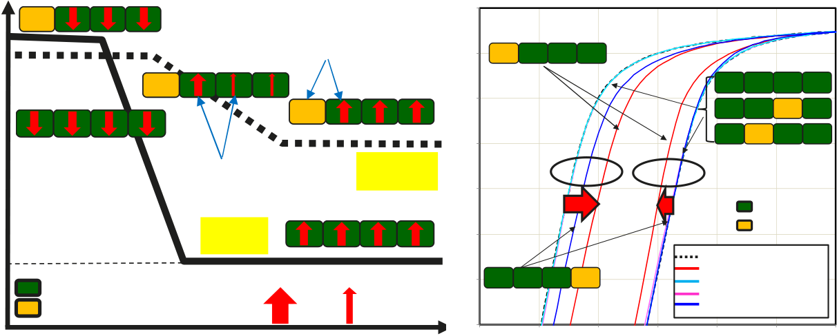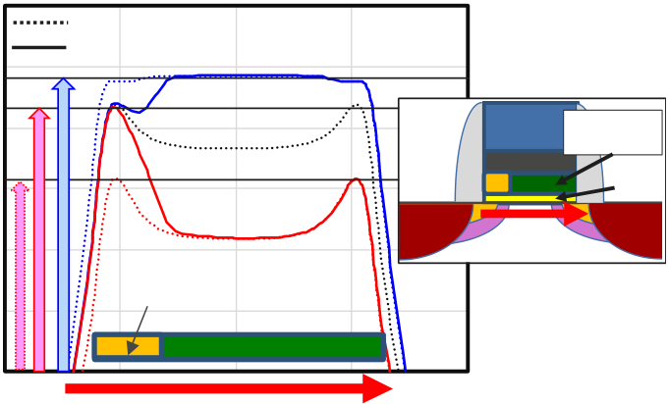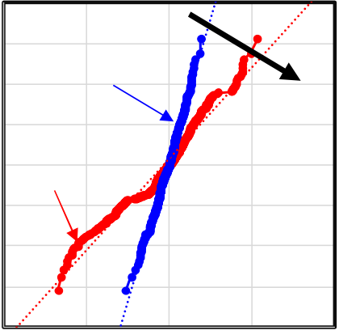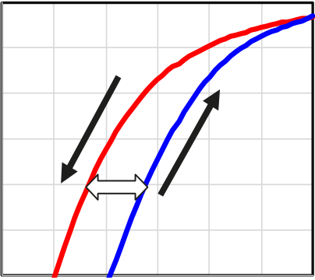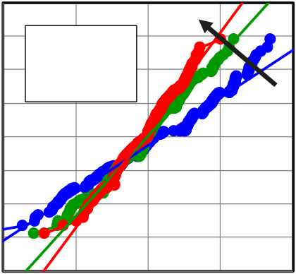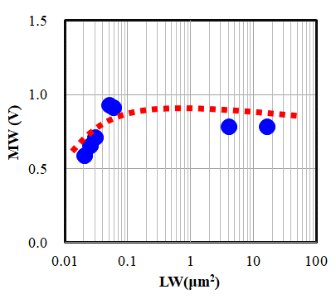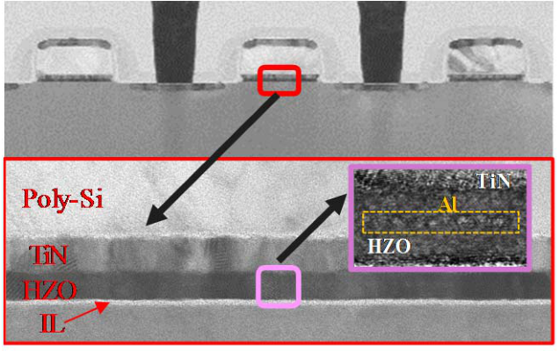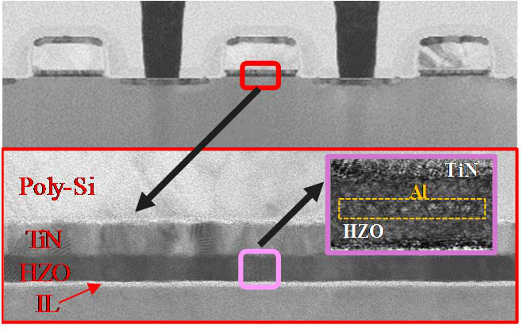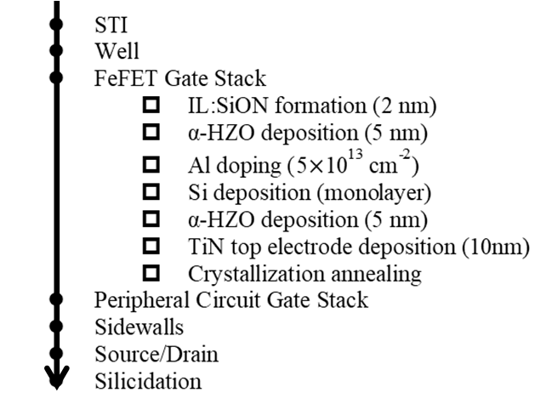

1.E-04

1.E-05 Low-Vth state

1.E-06

|  |  |
| --- | --- |
| Id [A] | 1.E-07 |

1.E-08

|  |  |  |  |  |  |  |  |
| --- | --- | --- | --- | --- | --- | --- | --- |
| 1.E-09 | -1 | -0.5 | MW | High-Vth state | | | 2 |
| 1.E-10 | Lg/Wg=240nm/260nm | | | |
| 0 | 0.5 | 1 | 1.5 |

Vg [V]

|  |  |  |
| --- | --- | --- |
| Fig. 1 Fabrication flow of the HZO based FeFET. | Fig. 2 TEM cross section of the HZO based FeFET. | Fig. 3 Id-Vg characteristics in the non-doped |

FeFET for the two polarization states.

4 1

3 0.8

2 High-Vth state 3s Vt=~180 mV 0.6

0.4   
 Relative MW (V)   
1 (high Vt) 0.2

0 Low-Vth state ~500 mV 0

σ

-0.2

-1

-0.4

-2 -0.6

-3 -0.8 Lg/Wg=240nm/260nm

-4 Lg/Wg=240nm/260nm -1

-1 -0.5 0 0.5 1 -1 -0.5 0 0.5 1

ΔVth (V) RelativeVth (V)

Fig. 4 The gate area dependence of Fig. 5 Cumulative frequency distribution of relative Fig. 6 The correlation of relative Vth

the memory window (MW) Vth after Vg sweep in the non-doped FeFET at low-Vth state and memory window (MW)

in the non-doped FeFET. for the two polarization states. in the non-doped FeFET.

1.E-03

100 Vth Polarization orientation

90 High-Vth state non-uniformity 1.E-04 **1**  **2**  **3**  **4**

80 FeFET: **1**  **2**  **3**  **4**

70   
 Low-Vth state 1.E-05

**1**  **2**  **3**  **4**

σVth/EOT [V/nm] Electrostatic potential [a.u.]   
 60 1.E-06 Low-Vth state **1**  **2**  **3**  **4**

Id [A/um] 50

40   
 FeFET:

High-Vth state   
 Domain growth

non-uniformity   
 Actual

1.E-07   
 High-Vth state

Ferroelectric

30 Paraelectric

20

10

Core NMOS   
 Low-Vth state

Ferroelectric domain   
 Ideal

[Domain growth rate]   
 1.E-08

1.E-09 **1** High-Vth state **2**  **3**  **4**   
 without Paraelectric domain

Paraelectric domain = 1

Paraelectric domain = 2

Paraelectric domain = 3

0 Paraelectric domain large small Paraelectric domain = 4

0 2 4 6 8 10 1.E-10

1/√LW [1/μm] Time 0 0.5 1 Vg [V] 1.5 2 2.5 3

Fig. 7 Vth variation divided by Fig. 8 Schematic illustration of Fig. 9 The simulated Id-Vg curve for

the dielectric thickness in the non-doped the polarization reversal behavior for FeFET. FeFET with and without polarization

FeFET and core NMOSFET (Pelgrom plot). orientation fluctuation.

4 4

w/ polarization orientation fluctuation

w/o polarization orientation fluctuation 3 High-Vth state 3 ●non-doped

High-Vth state 2 2 ●w/ Al

Poly Si Ferroelectric ●w/ Al+Si

No gate layer 1 1

Polarization state electrode

IL 0 0

σ

σ

Low-Vth state

-1 -1

Low-Vth state

paraelectric -2 -2

-3 -3

ferroelectric Lg/Wg=240nm/260nm L/W=120nm/260nm

-4 -4

-1 -0.5 0 0.5 1 -0.4 -0.2 0 0.2 0.4

• Source Position [a.u.] Drain• Relative Vth (V) Relative Vth (V)

Fig. 10 The simulated electrostatic potential along Fig. 11 Cumulative frequency distribution of relative Fig. 12 Cumulative frequency distribution

dielectric/Si substrate interface with and without Vth after Vg sweep in the FeFET with Al of relative Vth after Vg pulse

polarization fluctuation on the source side for the two polarization states. in the HZO based FeFET at low-Vth states.

of FeFET (Vg=0V).

15.4.3 IEDM19-352

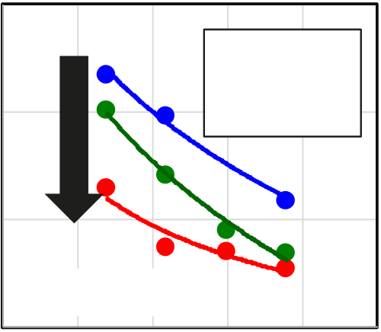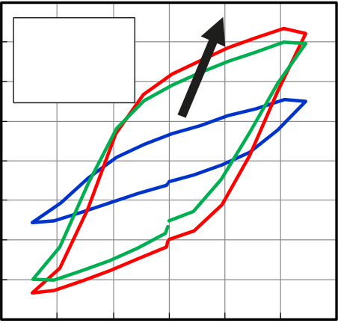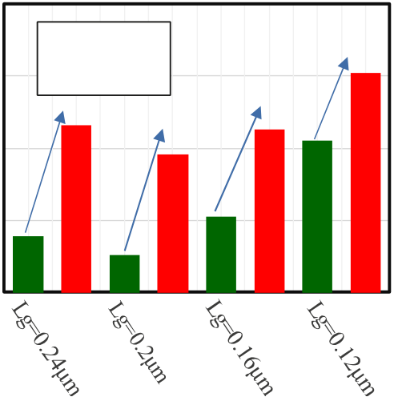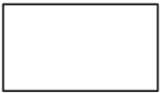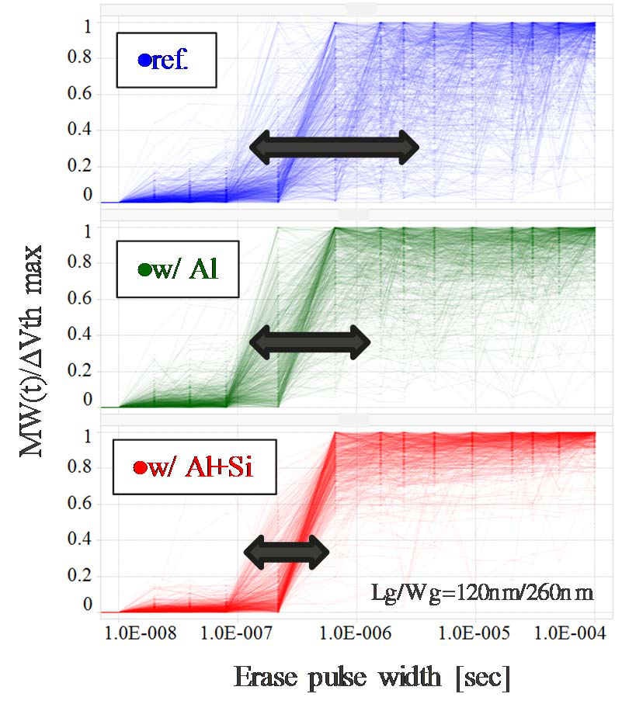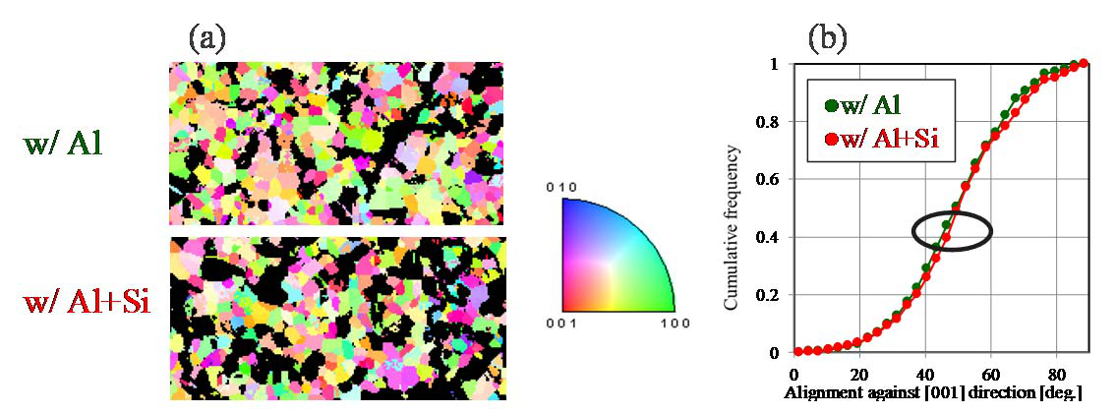

|  |  |  |  |  |  |  |  |  |  |  |  |  |  |  |  |  |  |  |  |  |  |  |  |  |
| --- | --- | --- | --- | --- | --- | --- | --- | --- | --- | --- | --- | --- | --- | --- | --- | --- | --- | --- | --- | --- | --- | --- | --- | --- |
| |  |  |  |  |  |  |  |  |  |  |  | | --- | --- | --- | --- | --- | --- | --- | --- | --- | --- | --- | | 0.20 ●non-doped●w/ Al   |  |  |  | | --- | --- | --- | | σVth (V) | 0.15 | ●w/ Al+Si | | 0.10 |   Wg=260nm  0.05   |  |  |  |  |  |  | | --- | --- | --- | --- | --- | --- | | 50 | 100 | 150 | 200 | 250 | 300 |   Lg (nm) | | Pr [uC/cm2] | 20 | - non-doped | | | | | | | Delta MW (V) | 0.4 | Fwi Al | Wg=260nm |
| 15 |
| - w/ Al | | | | | | |
| 10 | - w/ Al+Si | | | | | | | 0.3 | Awi Al/Si | |
| 5 | -3 | -2 | -1 | 0 | 1 | 2 | 3 | 0.2 | Fig. 15 The improvement amounts of | |
| 0 |
| -5 | 0.1 |
| -10 |
| 0 |
| -15 |
| -20 |
| Eg [MV/cm] | | | | | | |
| Fig. 13 The gate length (Lg) dependence of | Fig. 14 P-E hysteresis loop for metal- | | | | | | |
| Vth variation (σVth) in the HZO based FeFET | ferroelectric-metal (MFM) capacitor | | | | | | | MW (Delta MW) for the various gate | |
| at low-Vth state. | of the HZO film | | | | | | | length (Lg) to the non-doped FeFET. | |

|  |  |  |  |  |  |  |  |  |  |  |  |  |  |  |  |  |  |  |  |
| --- | --- | --- | --- | --- | --- | --- | --- | --- | --- | --- | --- | --- | --- | --- | --- | --- | --- | --- | --- |
| |  |  |  |  |  |  |  |  |  |  |  |  |  |  |  |  |  |  |  | | --- | --- | --- | --- | --- | --- | --- | --- | --- | --- | --- | --- | --- | --- | --- | --- | --- | --- | --- | | Area fraction [a.u.] | |  |  |  |  |  |  |  |  |  |  |  |  |  |  |  |  |  | | --- | --- | --- | --- | --- | --- | --- | --- | --- | --- | --- | --- | --- | --- | --- | --- | --- | |  | | | | |  |  |  |  | ■w/ Al ■w/ Al+Si | | | | | | | | |   grain size [a.u.] |

|  |  |
| --- | --- |
| Fig. 16 Crystal direction of orthorhombic grains in HZO film with the embedded Al nanocluster and with the Al nanocluster dispersed in Si-monolayer | Fig. 17 Grain size distribution of o-HZO grain. |

(a) Map, (b) Cumulative frequency of alignment angle against [001] direction in o-HZO grain.

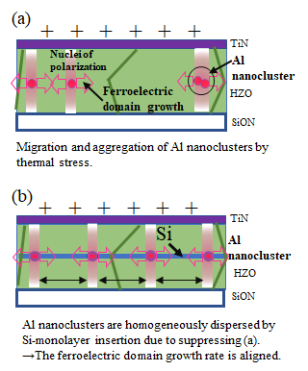

Fig. 18 Erase pulse width dependence of domain reverse probability (MW(t)/ΔVth max) for the HZO based FeFET.

Fig. 19 Schematic illustrations of the polarization reversal model for the HZO based FeFET with the embedded Al nanoclusters.

(a)w/o Si-monolayer, (b)w/ Si-monolayer

IEDM19-353 15.4.4